**Team event**

It will be a shooting game with 5 levels. Each level with increasing difficulty by changing the towers shape .

In each level, there will be a setting eg. shown in the figure. Here let us assume that the

**Purple**-easy to shoot

Yellow-medium difficulty

Green-difficult to shoot

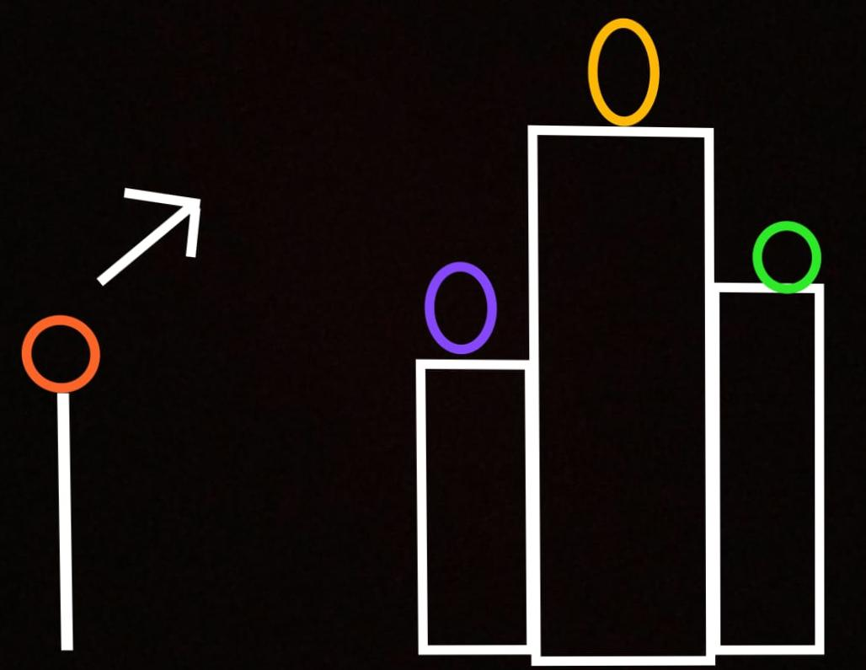Now, the person playing the game shoots the orange ball. If the orange ball hits the purple ball, the player would be given a difficult question to answer/solve. Similarly, shooting of green ball will result in easy question and shooting of yellow ball will result in medium level question.

This is the basic idea about our shooting game and we are still working on it.